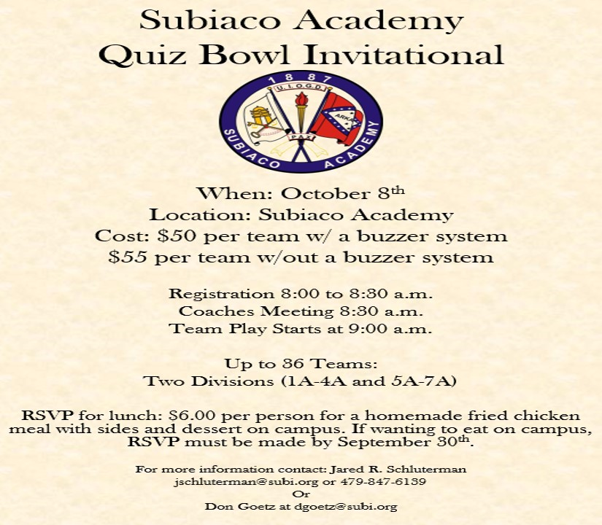
Subiaco Academy
Invitational Registration Form
School Name:
______________________________________

Coach's Name:
______________________________________

Coach's email:
______________________________________

School Address:
______________________________________

Coach's phone #:
______________________________________

Number of Teams ($50/team with a working buzzer system; $55/team without a buzzer system):
_____

Number of Buzzer Systems
_____

Number for Lunch ($6.00 per head)
_____

Total Amount:
$______

If paying in advance (preferred) make checks payable to Subiaco Academy Activities c/o Quiz Bowl and send to Jared Schluterman 405 N. Subiaco Ave. Subiaco, Ar. 72865

